**CHAPTER 18 SOLUTIONS**

**18.1.** According to the results of the chi-square goodness-of-fit test, students are not evenly divided into the two placement types, *p* = .008. Students are more likely to be placed in the resource room than in the self-contained classroom. The R command for obtaining the output is **chisq.test(table(Learndis$placemen))**

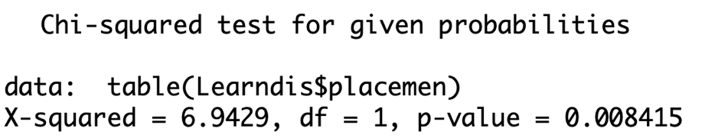

**18.2.**

a) According to the chi-square test of independence, there are no gender differences in the type of placement assigned, 2(*df* = 1, *N* = 66) = 1.15, *p* = .28. The R command for performing the test is: **chisq.test(table(Learndis$placemen, Learndis$gender), correct = F)**

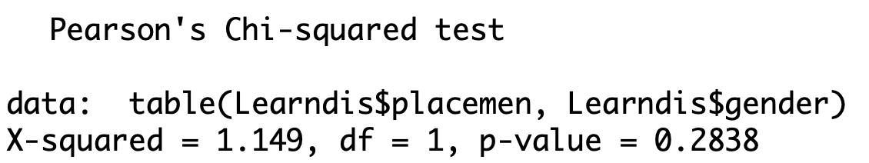

b) Correlation (in the case of two dichotomous variables, it is sometimes called the phi coefficient).

**18.3.**

a) According to the results of the sign test, such children perform better in math, *p* = 4.384e-05. The R command for performing the test is **SIGN.test(Learndis$mathcomp, Learndis$readcomp, alternative = "greater")**

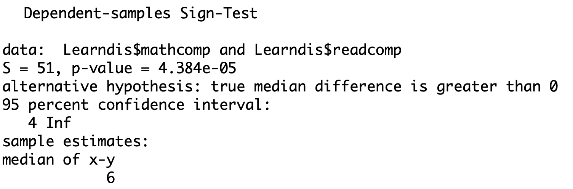

b) Yes.

**18.4.**

a) Because according to the skewness ratio, the distribution of reading comprehension scores is severely negatively skewed and the sample size is not adequately large to compensate.

b) According to the results of the Mann-Whitney U-test, students placed in the resource room are statistically significantly different in reading comprehension than students placed in self-contained classrooms, *p* = 2.437e-05. The R command for obtaining the test is **wilcox.test(Learndis$readcomp[Learndis$placemen == "RR"], Learndis$readcomp[Learndis$placemen == "MIS"], correct = F)**

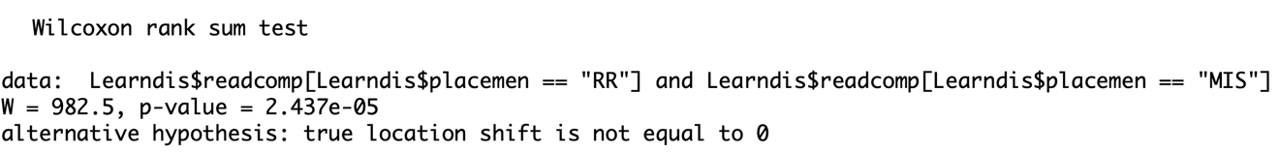

**18.5.**

a) Because the fourth grade reading comprehension scores are significantly skewed and the sample size is not adequately large to compensate.

b) Yes, 2(*df* = 4, *N* = 76) = 11.009, *p* = 0.02646. The R command used is **kruskal.test(Learndis$readcomp~Learndis$grade)**

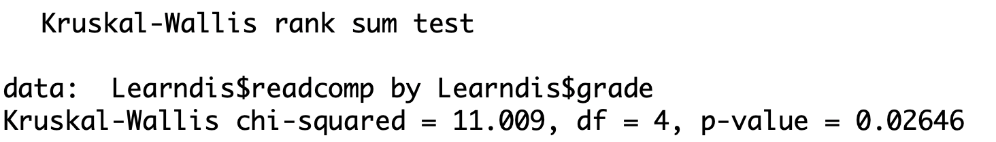

**18.6.**  The following answers are not necessarily the only correct choices.

a) iii

b) v

c) iii

d) iv

e) i

f) ii

g) ii

**18.7.**

a) The chi-square test of independence.

b) According to the chi-square test of independence, there are differences in urbanicity by region, 2(*df* = 6, *N* = 500) = 45.493, *p* = 3.735e-08. The R command for obtaining this result is **chisq.test(table(NELS$urban, NELS$region))**

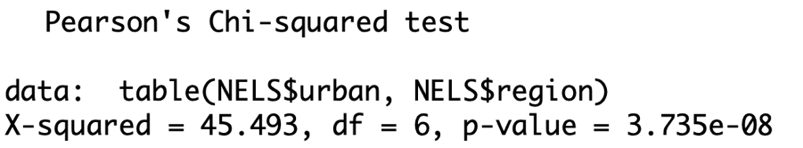

**18.8.**

a) The sign test.

b) Because the variables are measured at the ordinal level.

c) According to the results of the sign test, there is a statistically significant difference in the frequency of cut classes by seniors and the frequency of missed school by seniors, *p* < .0005. The R code to obtain this result is

**library(BSDA)**

**SIGN.test(as.numeric(NELS$absent12), as.numeric(NELS$cuts12))**

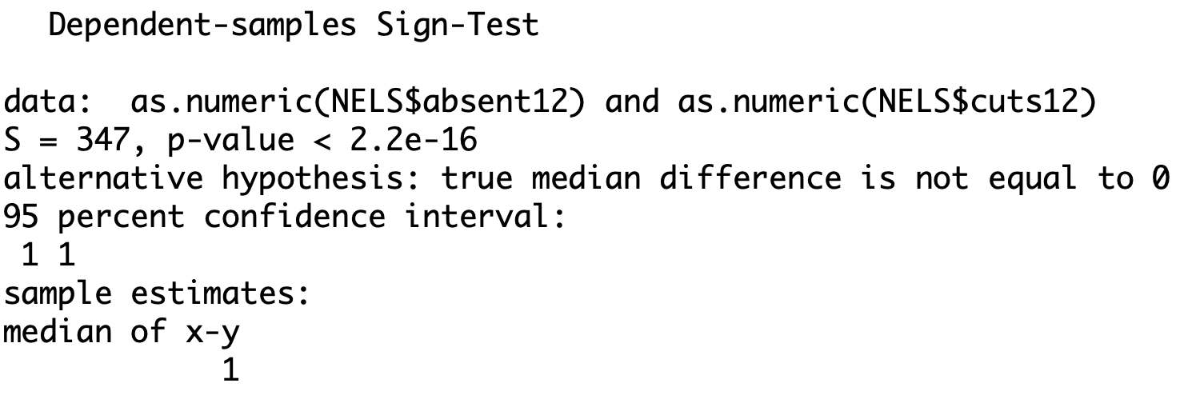

**18.9.**

a) The chi-squared test of independence and the Mann-Whitney U-test.

b) According to the results of the chi-square test of independence, perceived teacher interest in students does not vary by whether or not the student took advanced math in 8th grade, 2(*df* = 3, *N* = 491) = 4.65, *p* = 0.1993. The results of the Mann-Whitney U-test lead to the same conclusion, *z* = 1.67, *p* = .10.

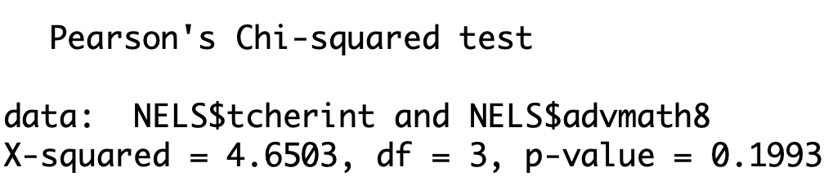

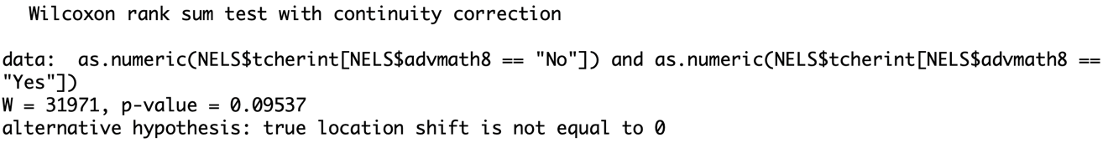

**18.10.**

a) The chi-square goodness-of-fit test.

b) According to the results of the chi-square goodness-of-fit test, college-bound students who are always at grade level report having ever smoked marijuana less often than the general population of high school seniors in the United States, 2(*df* = 1, *N* = 500) = 45.89, *p* < .0005. The R command to perform the test is **chisq.test(table(NELS$marijuan), p = c(0.674, 0.326))**

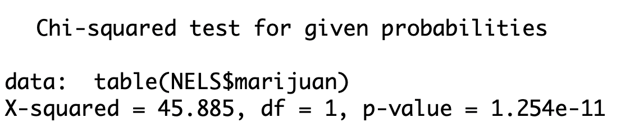

**18.11.**

a) A non-parametric test is appropriate in this case because hwkout12 is measured at the ordinal level.

b) The Kruskal-Wallis analysis of variance.

c) According to the results of the Kruskal-Wallis Test, time spent on homework outside school by high school seniors does vary by urbanicity, 2(df = 2, N = 500) = 15.17, p = 0.0005083. The R command is **kruskal.test(NELS$hwkout12 ~ NELS$urban)**

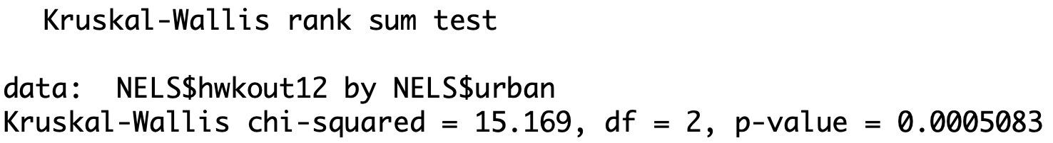

**18.12.**  According to the results of the chi-square goodness-of-fit test, these doctors detected statistically significantly fewer positive results than the state average, 2(*df* = 1, *N* = 10000) = 29.40, *p* < .0005.

The R command for entering these data and conducting the test are:

**chisq.test(c(13, 9987), p = c(0.0052, .9948))**

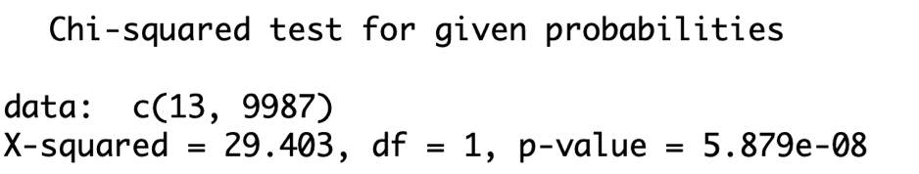

**18.13.**  According to the results of the chi-square test of independence, there is no association between estrogen use and cardiovascular death rates, 2(*df* = 1, *N* = 1500) = 2.60, *p* = .11.

The R commands for entering the data and running the test are:

**data = matrix(c(746, 4, 740, 10), 2, 2, byrow = T)**

**chisq.test(data, correct = F)**

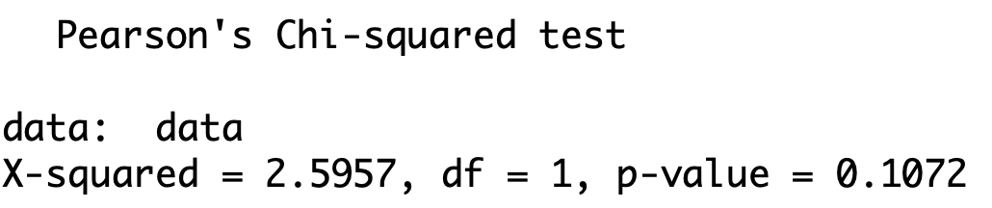

**18.14.**  According to the results of the sign test, the education level of first-born sons in the small rural community in the Midwest is different than the education level of their fathers, *p* = .003.

The R commands for entering the data and running the test are:

**sons = c(3,3,3,5,6,4,3,5,2,4,4,1,4,3,6)**

**fathers = c(1,2,1,3,3,2,3,4,3,3,2,1,2,2,4)**

**library(BSDA)**

**SIGN.test(sons, fathers)**

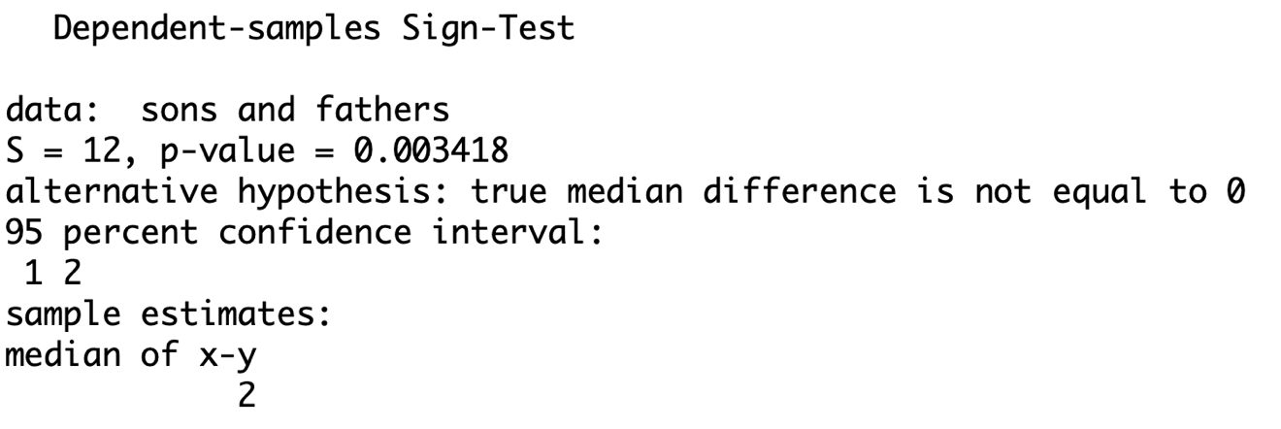

**18.15.**  According to the results of the Mann-Whitney U-test, the competitiveness of siblings of the same sex is not different than siblings of the opposite sex, p = 0.07526.

The R commands for entering the data and performing the test are:

**same = c(15, 23, 38, 35, 29, 22, 31, 26, 39, 36)**

**opposite = c(24, 25, 16, 10, 13, 18, 9, 37, 27, 33)**

**wilcox.test(same, opposite)**

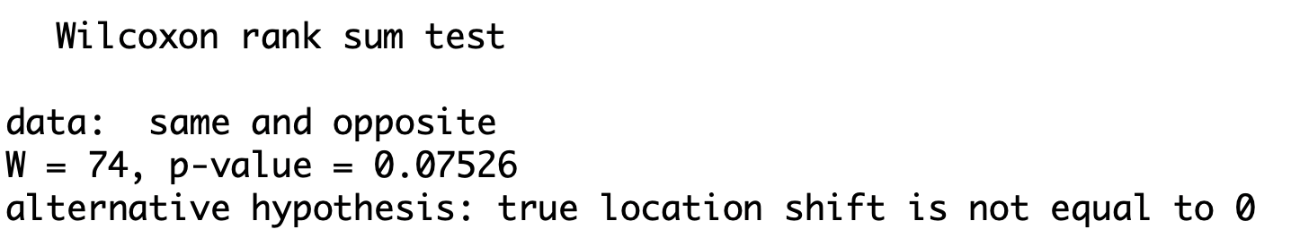

**18.16.** According to the results of the Kruskal Wallis test, there were differences in mood by type of music heard, 2(*df* = 2, *N* = 12) = 9.85, *p* = .007.

The R commands for entering the data and producing the test are:

**data = c(1,3,4,2,5,8,6,7,9,12,11,10)**

**type = as.factor(c(rep("Slow Classical", 4), rep("Soft Rock", 4), rep("Hard Rock", 4)))**

**kruskal.test(data~type)**

